

Azure Site Recovery (ASR) Deployment Guide
Hyper-V with VMM

10th Magnitude, LLC
20 North Wacker Drive #530
Chicago, IL 60606

Notice of Confidentiality © 2018 10th Magnitude, LLC All rights reserved

THIS DOCUMENT IS 10TH MAGNITUDE PROPRIETARY AND CONFIDENTIAL INFORMATION AND IS SUBJECT TO THE TERMS OF THE 10TH MAGNITUDE NON-DISCLOSURE AGREEMENT. NEITHER THIS DOCUMENT NOR ITS CONTENTS MAY BE REVEALED OR DISCLOSED TO UNAUTHORIZED PERSONS OR SENT OUTSIDE THE AFOREMENTIONED COMPANY WITHOUT PRIOR PERMISSION FROM 10TH MAGNITUDE.
Table of Contents
Summary 3
ASR Deployment 3
Prepare On-Prem and Azure Environments 4

Summary
This is a general high-level step-by-step guide for deploying Azure Site Recovery (ASR) Hyper-V standalone specific on-prem environment.

ASR Deployment
Before you start, it’s a good idea to review the Microsoft ASR Setup Guide to get a clear understanding of the architecture and what needs to be deployed to support the migration.

Useful reference links:
https://docs.microsoft.com/en-us/azure/cloud-solution-provider/migration/on-premises-to-azure-csp/asr-capacity-planning
https://docs.microsoft.com/en-us/azure/cloud-solution-provider/migration/on-premises-to-azure-csp/asr-setup-guide
https://docs.vmware.com/en/VMware-vSphere/6.5/com.vmware.vsphere.vm_admin.doc/GUID-17BEDA21-43F6-41F4-8FB2-E01D275FE9B4.html

Prepare On-Prem and Azure Environments
- Create Resource Group in each target subscription and region for the Azure Site Recovery components.
- Create the ASR components in each target subscription and region in the ASR Resource Group.
  - Create a Storage Account to be used as the ASR cache, this can be a Standard performance tier account.
  - Optionally create an additional Storage Account at the Premium performance tier for workloads that need additional performance, for example SQL workloads.
  - Create a testing VNET and at least one subnet, if needed.
  - Create an NSG to isolate the testing VNET and apply it the subnets.
  - Create a Recovery Services Vault.
- Prepare the ASR Infrastructure
  - In the Azure portal, open the Recovery Service vault
  - In the Site Recovery section, click Getting Started, then Prepare Infrastructure

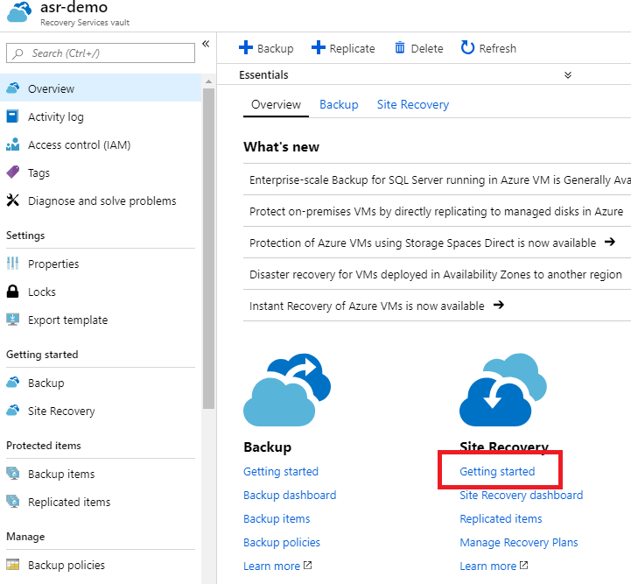

  - In the Protection goal step > Where are your machines located, select On-premises. Where do you want to replicate your machines, select To Azure. Are your machines virtualized, select Yes, with Hyper-V. Click OK. Are you using System Center VMM to manage your Hyper-V hosts? Select Yes.

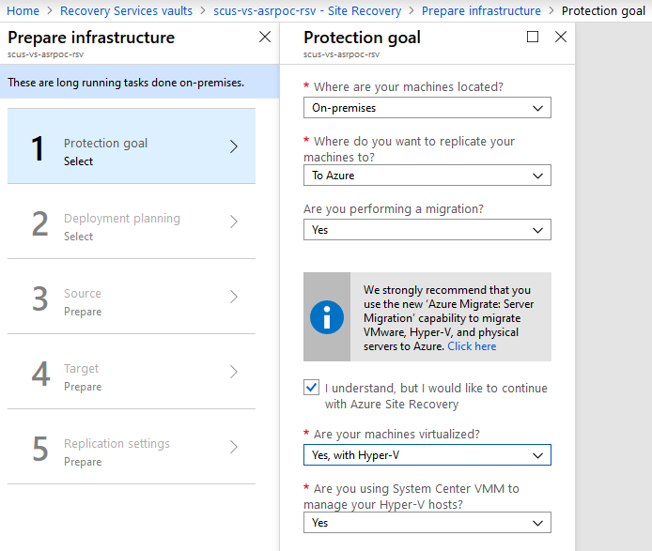

  - Deployment Planning > Yes, I have done it. Click OK.

  - Prepare the source environment by registering the VMM server and the Hyper-V hosts. You’ll need to download and install the ASR provider and register the VMM server and each Hyper-V host to the Recovery Services Vault.

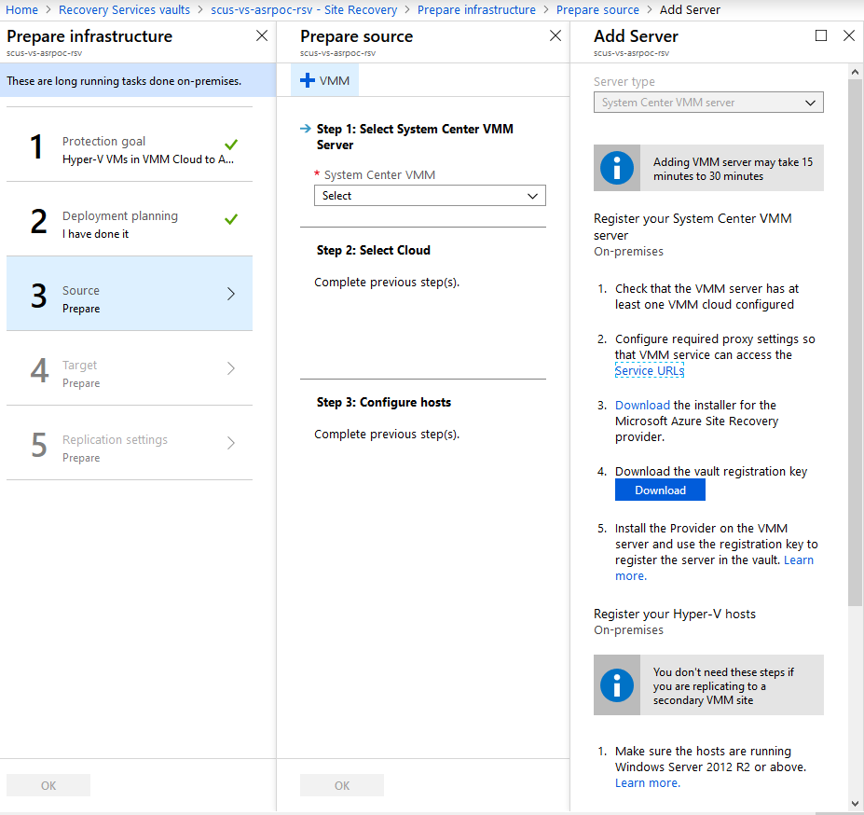

To register the VMM server:
- Check that the VMM server has at least one VMM cloud configured. Take note of the cloud that will be the source. You’ll need to select it during the ASR provider installation.
- Configure required proxy settings so that VMM service can access the Service URLs
- Download the installer for the Microsoft Azure Site Recovery provider.
- Download the vault registration key
- Install the Provider on the VMM server and use the registration key to register the server in the vault.

ASR Provider installation with default options:

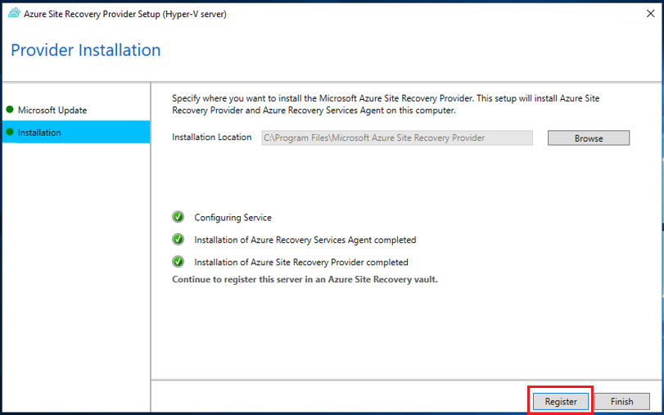

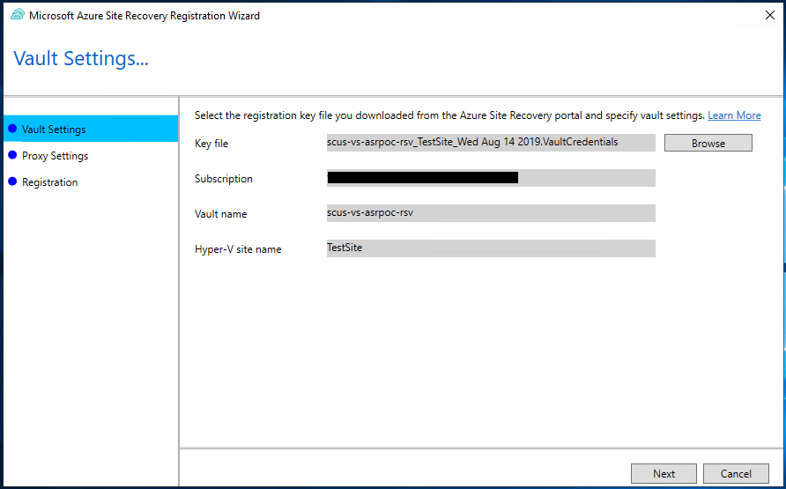
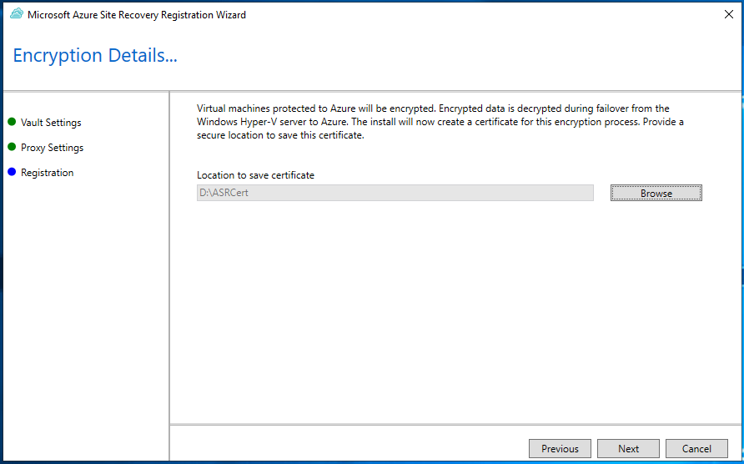

Make sure Sync Cloud Metadata is selected:

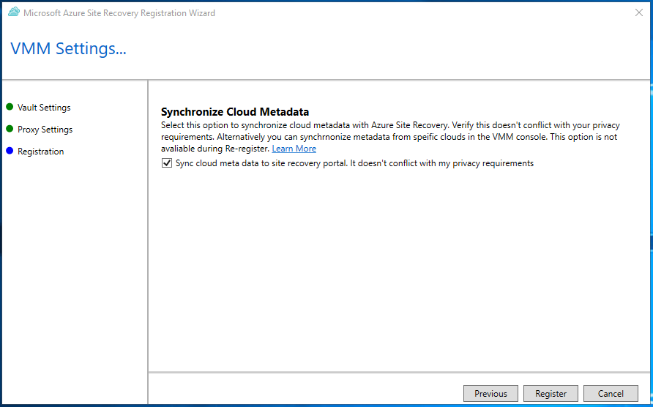
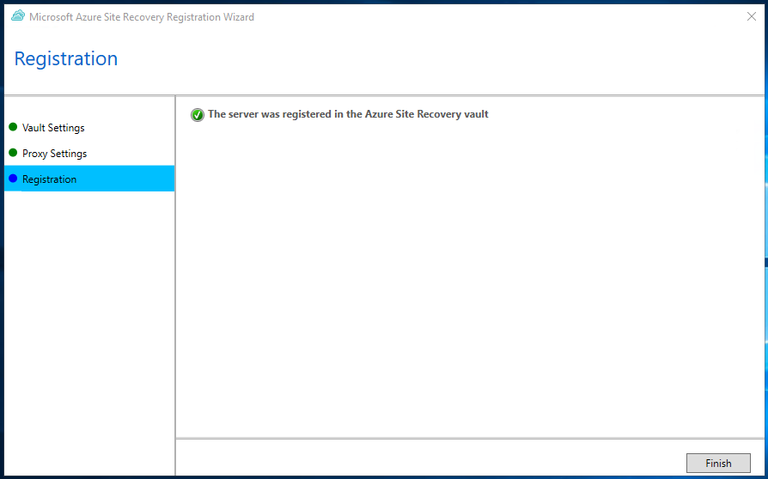

To register the Hyper-V hosts:

- Make sure the hosts are running Windows Server 2012 R2 or above.
- Check that Hyper-V hosts are assigned to appropriate VMM cloud
- Configure Proxy Settings so that Hyper-V host can access Service URLs
- Download the installer for the Microsoft Azure Recovery Services agent
- Download the Vault Registration Key and save it.
- Run the installer on each Hyper-V server in the VMM cloud to install the agent and use the registration key when prompted to register the host in the Recovery Services Vault.

ASR provider host installation using install defaults:

  - Now that the servers have been registered, they should be available to add in the Prepare Source step. Adding the servers can take some time, up to 15 mintues for them to show up in the vault. You may have to exit out of the prepare infrastructure wizard and restart it to pick up the new hosts. Select the VMM server and the Cloud that will be associated with the migrating servers.

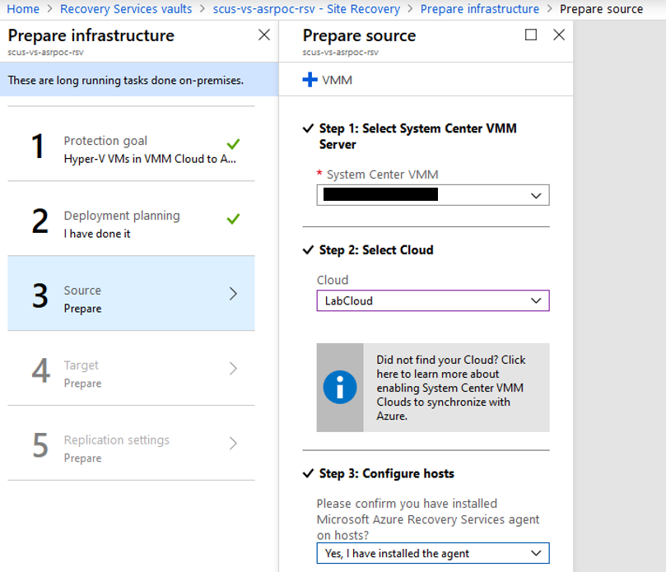

  - Next, you’ll need to configure your target environment. Select the target subscription and optionally a storage account and network. These can be configured later, but you’ll need at least one compatible storage account and network. If these don’t exist, you can create them from this wizard.

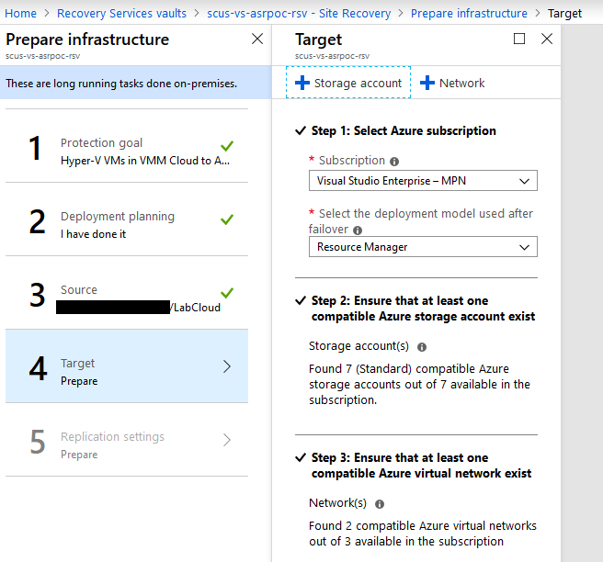

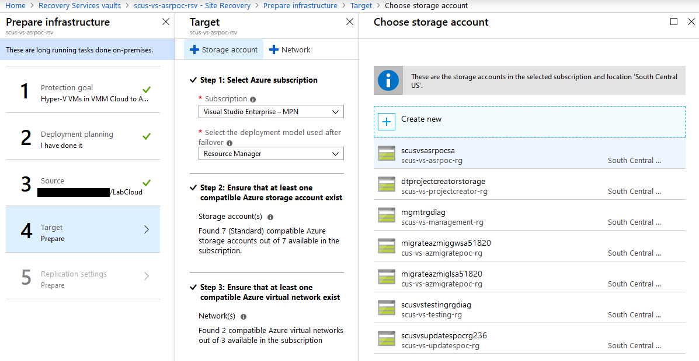

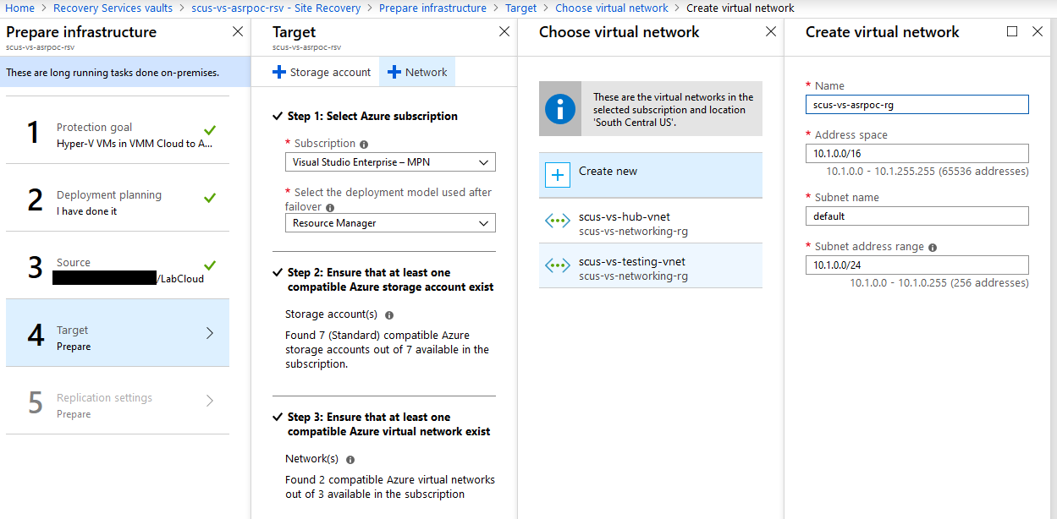

  - Lastly, create and associate a replication policy that meets the RPO target, or you can associate an existing policy by clicking the Associate button.

